
INTRODUCTION


PROJECTSCHEDULE

System Engineering

Requirement Analysis

Design

Coding

Testing



REQUIREMENTSANALYSIS


DESIGN

Analysis Modeling

System Design Calls: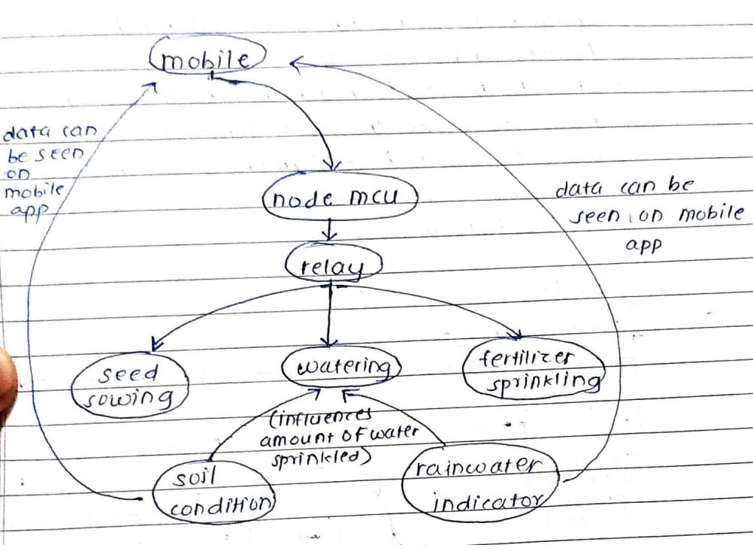
Fig1.1
Characteristics of Embedded systems:

- Embedded Systems :

Embedded systems are computer systems that perform specific functions within a larger system. They have many characteristics, including:
Real-time operation: Embedded systems must react to changes in their environment and compute results in real time without delay. For example, a car cruise controller monitors and reacts to speed and brake sensors.
Reactivity: Embedded systems must be reactive to their environment. For example, a pilot controlling an aircraft is a reactive real-time system.
Time specific: Embedded systems must operate within a specific time frame.
Low cost: Embedded systems are typically designed to be cost-effective.
Compact size: Embedded systems are designed to be small in size and weight.
Energy efficient: Embedded systems are energy efficient.
Application-specific: Embedded systems are designed for one specific task.
Modular design: Embedded systems have a modular design.
Easy connectivity: Embedded systems have ease of connectivity.


IMPLEMENTATION
`



TESTING REPORT



PERFORMANCEANALYSIS


INSTALLATION GUIDE


USERMANUAL

USER MANUAL

Step1:Run the bot

Step2:Insert the sensors into the soil

Step3:Check readings on the app

Step3:Allowthewebcameratocaptureyouremotionsandclickonrecommendsongs



Step 4: Nowyouwill be redirectedtoyoutube anditwill recommendsongsbased on your real time emotions captured



RESULT

– Capturing Soil Condition:
- Soil Moiture :
- Soil pH:

– Capturing Rain Condition:

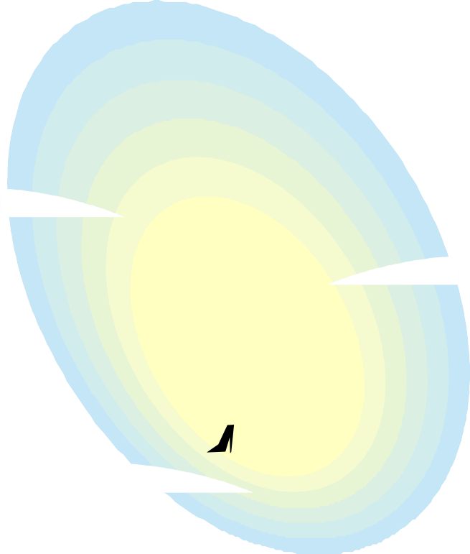

APPLICATION


BIBLIOGRAPHY

